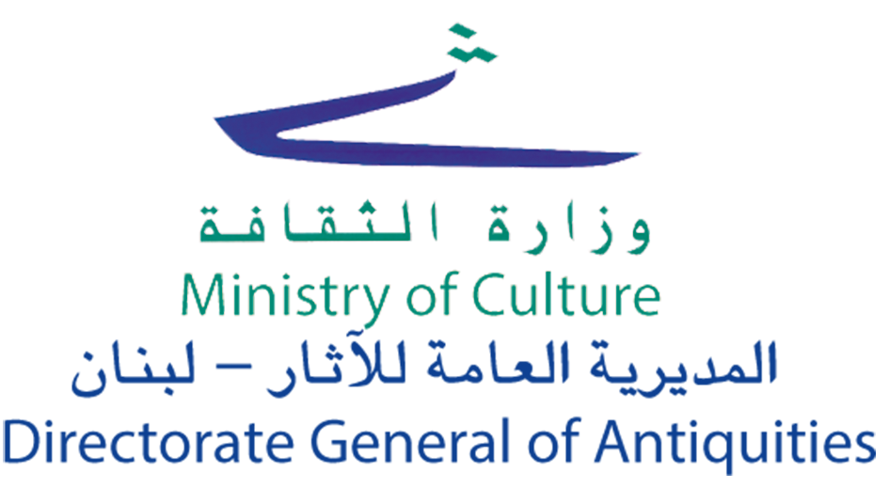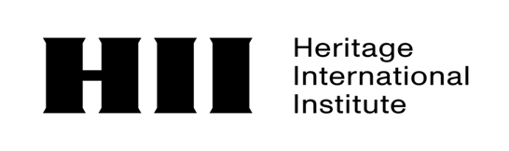
ARCHIVING LEBANON’S HERITAGE
A JOINT CALL BY THE MINISTRY OF CULTURE/DIRECTORATE GENERAL OF ANTIQUITIES (DGA) AND HERITAGE INTERNATIONAL INSTITUTE (HII) FOR THE FIRST GLOBAL ARCHIVE OF LEBANESE LEGACY
International Call for the Collection, Documentation and Conservation of Cultural and Digital Heritage
In a historic and unprecedented joint initiative, the Ministry of Culture/Directorate General of Antiquities (DGA) of Lebanon and the Heritage International Institute (HII) an Italian based international centre of excellence dedicated to the preservation, protection, and promotion of heritage, have launched a major safeguarding initiative: the creation of the first Global Archive of Lebanese Heritage. This secure and permanent digital repository is dedicated to preserving Lebanon’s tangible and intangible, cultural heritage for future generations.
Born from the Cooperation Agreement signed between the two institutions on May 31st, 2026 during the international summit in Parma, DGA and HII have united their expertise into a single, powerful alliance. HII brings its international network of professionals to support this mission, operating under its core mandate to safeguard cultural treasures both during times of conflict and peace, thereby fostering international security, human rights, and sustainable development.
Cultural heritage is an essential resource for understanding the history, identities, and relationship between communities and territories. In line with UNESCO principles, its preservation requires the active involvement of citizens and communities, custodians of memories, knowledge and traditions. This International Call invites contributions to the collection and preservation of Lebanon’s tangible and intangible cultural heritage as well as cultural landscape, along with digital heritage, with the aim of creating an open, permanent and participatory digital archive in support of collective memory, research, education and the transmission of cultural legacies to future generations. Your footprint today will secure Lebanon's heritage tomorrow.

THE FOUR PILLARS OF OUR HERITAGE
Every document you share becomes part of a monumental global database powered by the combined network of DGA and HII.
The archive may include materials in different documentation formats such as audio recordings, audiovisual recordings, written transcriptions (such as old family letters, diaries, historical manuscripts, or ancestral land deeds), photographs, postcards, and field documentation. Every document is valuable.

1. TANGIBLE HERITAGE
- Historical Photographs: People, Daily Life, Landscapes, Historical Monuments, Traditional Buildings and Architecture, Historic Centres and Towns, Archaeological Sites, Places of Worship, Industrial Heritage, Modern Architecture, Works of Art.
- Maps and Architectural Plans: Documents illustrating changing geographic or structural landscapes. Geographical Maps and Cartography.
- Personal Correspondence and Diaries: Letters and Journals. Personal reflections that document lived experiences and personal histories.
- Manuscripts, Publications, and Family Archives: Published and Unpublished Texts, Private Collections, Administrative and Community Archival Records, and Genealogical Collections.

2. INTANGIBLE HERITAGE
- Oral traditions and expressions: Spoken testimonies, or Documented Folklore, Stories, Folktales, Legends, Fairy Tales, Local Memories & Accounts, Proverbs, Dialects, Local & Minority Languages, Oral Testimonies & Interviews.
- Performing arts: Traditional Songs, Traditional Dances, Folk Theater, Community Performances.
- Social practices, rituals, and festive events: Local Festivals & Feasts, Religious Celebrations, Traditional Ceremonies, Community Events, Historical Commemorations.
- Knowledge and practices concerning nature and the universe: Agricultural Knowledge & Farming Traditions, Traditional Livestock Breeding Techniques, Traditional Environmental Knowledge, Seasonal Calendars, Traditional Management of Natural Resources, Climate & Territorial Knowledge.
- Traditional craftsmanship: Craft Techniques, Historical Trades & Crafts, Traditional Productions, Traditional Tools & Technologies, Transmission of Professional Knowledge & Expertise.
- Culinary traditions: Authentic recipes, recorded traditional cooking, cultural food stories

3. CULTURAL LANDSCAPE
- Sacred Cedar Forests & Ancient Trees
- Biosphere Reserves & Protected Areas
- Protected Valleys
- Historical & Natural Rivers
- Agricultural Stone Terraces & Historical Cultural Landscapes
- Ancient Caves & Geological Formations
- Unique Local Biodiversity & Wildlife Ecosystems
- Traditional Environmental & Climate Descriptions

4. DIGITAL HERITAGE
The initiative also accepts materials that are already in digital form, recognizing their significance as key components of modern memory. It aims to promote their preservation, enhance their value, and ensure they are accessible. Archives, websites, blogs, photos, audio and video recordings, digital maps, social content with historical or community significance, as well as digital memory projects, can be shared. Contributions may be transmitted either in digital native format or as digitized copies of analog materials.

WHAT YOU CAN SHARE
Whether your contributions are historical or recent, professional or personal, every piece of data is a vital component of this digital fortress. We accept:
- Documents: Letters, Diaries, Manuscripts, Registers, Maps, Drawings, Publications, Archival Materials.
- Photographs: Historical Photographs, Contemporary Photographs, Family Collections, Digitized Images.
- Audio: Interviews, Oral Testimonies, Songs, Traditional Music, Environmental Recordings (Soundscapes), Local Memory Stories, Archival Concerts.
- Video: Documentary Films , Historical Footage, Traditional Events, Rituals, Craft Techniques, Testimonies, Cultural Landscapes & Natural Environments, home movies, Archival Concerts and Performances.
The archival value of such materials lies in their capacity to document and preserve historical states of places, environments, and cultural practices, beyond their original personal or domestic context.

SHARE THE STORY BEHIND YOUR MATERIAL
Wherever feasible, each contribution must come with pertinent details necessary for proper documentation, such as: title, description, location, date, creator or owner, historical-cultural background, heritage classification, and any rights or permissions.
When you submit your materials, we invite you to briefly introduce yourself and the story behind what you are sharing. You can include a short-written note, or a 30–60 second video/audio recording explaining:
- Who you are and your connection to Lebanon
- What you are sharing and where/when it comes from
- Why it matters to you, your family, or your community
This will help us preserve not only the material itself, but also the living memory, emotion, and context behind it.

BECOME A GUARDIAN OF LEBANESE MEMORY: THE HONORARY DISTINCTION
Your contribution is far more than a digital submission—it is an active act of cultural preservation to make Lebanon's heritage immortal. To honor the exceptional individuals, families, and organizations that step forward to protect the soul of our nation, HII and the DGA have established the prestigious honorary distinction: "Guardians of Lebanese Memory."

The Stage: A Grand Gala Launch in Rome
The culmination of this global rescue operation will be celebrated through The Grand Gala Launch: Unveiling the Digital Global Archive.
- The Global Stage: Hosted in Rome—the historic crossroads of Mediterranean civilizations—this high-level diplomatic event will gather state dignitaries, international diplomats, cultural leaders, and global media under the joint patronage of the DGA and HII.
- The Digital Bridge: The event will be broadcast live through the Lebanese Ministry of Culture podcast

The Award Ceremony: Three Laurels of Excellence
The absolute highlight of this international evening will be the official Award Ceremony. Based on rigorous scientific criteria jointly established by the DGA and HII, three international laureates will be solemnly presented under the global spotlight across three categories:
- The Depth of Time Laurels: For the earliest verified photographic, textual, or documentary evidence of Lebanese socio-cultural life.
- The Voice of Identity Laurels: For the most invaluable rescue of intangible heritage, rare oral testimonies, or forgotten communal practices.
- The Community Anchor Laurels: For the diaspora family, school, or association mobilizing and submitting the largest verified collective archival fund.

A Permanent Legacy
All laureates will be officially decorated and presented with a National Heritage Diploma co-signed by both DGA and HII Leadership. To cement their legacy, their names will be permanently enshrined in the "Wall of Honor" of the new Open Access Portal, marking their historic transition from contributors to active saviors of the Lebanese National Collective Memory and Heritage.

A SHARED MEDITERRANEAN BRIDGE: THE ITALIAN CONNECTION
To enhance the scientific depth of this initiative, the Archive is backed by a prestigious international collaboration with Italian cultural heritage networks and academic experts, subject to the prior written approval of both DGA and HII in accordance with the Implementation Agreement. Rome—the historic crossroads of Mediterranean civilizations—does not only serve as the stage for our Grand Gala Launch but also acts as a scientific bridge.
Through this partnership, the Archive will unlock historical, archaeological, and cultural interconnections between Lebanese and Italian heritage. What does this mean for your contributions?
- Comparative Scientific Research: Renowned scholars will study and document the ancient, shared links between Italian and Lebanese history directly within the Archive's database.
- Advanced Technical Standards: Leading digital humanists will support the platform’s indexing and long-term digital preservation protocols.
- Global Visibility: This collaboration will foster joint open-access virtual exhibitions, bringing the stories of the Lebanese diaspora onto the European and global cultural stage.

JOIN AS A COLLABORATOR
We also invite students, researchers, artists, filmmakers, anthropologists, architects, historians, and digital heritage practitioners to join this effort. Contribution may include oral history interviews, family archive digitization, local mapping, cataloguing, translation, metadata work, interpretation of cultural heritage materials, photographic documentation, or short video testimonies.

ETHICAL PRINCIPLES
Every contribution must uphold individual and communal dignity, ensure privacy protection, respect cultural rights, and accurately credit material authors. The project operates in alignment with international FAIR principles (for open science) and CARE principles (for the ethical management of cultural data), fully protecting Lebanon's national interests.

WHO CAN PARTICIPATE
The call is open to citizens, families, local communities, associations, schools, universities, researchers, museums, archives, libraries, public bodies, and cultural organizations.

JOINT OWNERSHIP AND GOVERNANCE
In accordance with the Implementation Agreement signed between the DGA and HII, the databases, metadata, and archival platform developed within this project shall be jointly owned and governed by the DGA and HII. The DGA provides institutional leadership and advocacy as the sole official custodian of Lebanese heritage. HII acts as a technical service provider, hosting and maintaining the core infrastructure under an arrangement within the certified repository framework of DARIAH-IT in Italy.

COPYRIGHT AND INTELLECTUAL PROPERTY RIGHTS

1. Ownership of Submitted Materials
Contributors retain full ownership of all copyright and any other intellectual property rights over all materials they submit to the Archive, including photographs, videos, audio recordings, documents, texts, oral testimonies, and any other creative or informational content.
No transfer of copyright occurs under this Call or the associated Implementation Agreement.

2. License Granted to the DGA and HII
By submitting materials, contributors grant the DGA and HII a non-exclusive, royalty-free, worldwide license to:
- Receive, store, preserve, digitize, catalogue, and manage the submitted materials;
- Publicly display the materials.
- Use the materials for the purposes of the First Global Digital Archive of Lebanese Identity, including research, education, exhibitions, and publications, This license does not affect the contributor's right to use, publish, share, or license their own materials independently.
- The contributor may exceptionally refuse the display of his document. In that case, it has to be clearly mentioned in a special section.

3. Attribution and Crediting
Contributors may choose how they wish to be credited (see Crediting options below). The DGA and HII shall respect the contributor's choice and include appropriate copyright notices where required.

4. Archival Preservation
The DGA and HII may retain archival copies of submitted materials where necessary to ensure the integrity, continuity, and long-term preservation of the Archive, even where access restrictions are subsequently modified, provided that such retention remains consistent with the permissions granted by the contributor.

5. No Unauthorized Commercial Use
Neither the DGA nor HII shall use the submitted materials for any commercial purpose outside the scope of this non-profit cultural heritage project without obtaining separate, explicit written consent from the copyright owner.

RIGHTS, CONSENT, AND SENSITIVE HERITAGE
Consent Options: To protect both contributors and communities, we ask you to confirm that you created the material or have permission to share it. The contributor may exceptionally refuse the display of his document. In that case, it has to be clearly mentioned in a special section.
Crediting: You can choose to be credited via your Full name, Initials, Family/Community name, or remain Anonymous.
Note on Sensitivity: If your material includes private homes, sacred practices, displaced communities, rituals, or sensitive locations, please let us know. Some heritage should be preserved with care and does not need to be made public. Such materials will be flagged as "Sensitive Heritage" and will remain permanently locked inside the secure private archive.

SECURITY AND DATA GOVERNANCE
The documents will be kept in digital archives, which will be secured through proper safety measures, backups, and long-term preservation techniques. Personal data will be processed in compliance with current legislation. Both the DGA and HII have full, direct, and real-time access to all stored data at all times. Materials with contemporary political or sensitive features will be excluded by mutual agreement to maintain the strict cultural nature of the archive.

HOW TO CONTRIBUTE TO THE DIGITAL ARCHIVE
The digital repository serves as a shared space where anyone can post and exchange files pertinent to their activities, experiences, or cultural heritage, thereby aiding in the creation of a discoverable and well-organized shared memory.

1. Loading material
Each contribution is accompanied by:
- Title
- Brief description
- Place and date (if available)
- Author or owner of the material
- Any additional information useful for contextualization

2. Classification by type
Upon loading, the material is placed into one of the main technical categories:
- Professional photographs
- Amateur photography (smartphones, personal albums, etc.)
- Professional videos
- Amateur videos
- Audio recordings
- Oral Testimonials
- Archival documents and materials
- Articles and publications
- Mixed media materials
This distinction allows us to identify the technical quality and nature of the content without excluding any contribution.

3. Classification by topic
- Architectural and monumental heritage
- Cultural landscapes
- Food traditions and agricultural practices
- Performing arts (music, dance, theatre)
- Traditional craft
- Community festivals, rituals and events
- Historical memory and testimonies
- Languages and oral traditions
- Knowledge related to nature and the environment
- Traditional productive activities and trades
- Archaeological heritage
- Natural heritage and biodiversity

4. Sending Mode and Secure Data Transmission
To ensure maximum security and proper ingestion into the secure archive infrastructure hosted in Italy, materials can be transmitted through the following official channels:
- Official Joint Online Form: (INSERT LINK) (Direct upload to the secure interface managed by HII)
- Direct File Transfer Services: sent to the official project repository.
- Dedicated Institutional E-mail: (INSERT E-MAIL)
- Verified Project WhatsApp: (ENTER NUMBER)
Collection and digitization days will also be jointly organized by the DGA and HII at museums, libraries, archives, schools, and cultural centers.

NEED HELP? WE ARE HERE FOR YOU
Don’t let technical issues or physical formats stop you! If your precious memories are still on paper, old film, audio cassettes, or if you simply don’t know how to upload them, the DGA and HII expert networks are here to help you protect them:
- WhatsApp Technical Support: Text or call our dedicated heritage lifeline at (ENTER NUMBER) and the HII technical team will guide you step-by-step through the secure submission process.
- Email Assistance: Send your technical questions or archive files directly to (INSERT E-MAIL).
- Physical Materials & Digitization Missions: If you possess historical objects, delicate diaries, or ancestral photo albums that you cannot digitalize yourself, contact us. The DGA and HII will arrange a secure method to document and digitize them during our upcoming joint institutional missions or through our authorized local networks.
Each document, photograph, testimony or tradition represents a part of the collective memory. Contributing to this initiative means participating in the preservation of cultural heritage and its transmission to future generations.
Join the Ministry of Culture/Directorate General of Antiquities (DGA) and the Heritage International Institute (HII) in Documenting and Safeguarding Lebanon’s Cultural Heritage.

